Servas Canada
Newsletter 16 - May 2008

IN THIS ISSUE
1. Message from the President of Servas International
2. Servas International celebration of 60 Years
3. International '08 Servas Youth Meeting
4. Servas Canada Board meeting in November 2007
5. Servas Canada Operating Expenses
6. Servas Malawi Deputy Secretary visits Canada
7. Extracts from an enthusiastic traveler’s report
8. Bits and Bats
a. 2008 Host List
b. Project Funding

1. Message from the President of Servas International
Gary Sealey, President of Servas International, in his New Year message to the various leaders of Servas around the world, thanked them for their dedication to the organization. “Your personal efforts are building an important Servas global and local network of helpful friendships leading to planetary peace,” he wrote. He reminded them, and all members of Servas, to take advantage of the many Servas activities posted each month at: http://www.servas.org/siexco/index.php/Servas_International_News
For those who like planning their trips in advance, do remember that the next General Assembly of SI will be held in 2009, possibly in India or Korea, who have both offered to host this exciting event. Attend the assembly then tour the country!
Another event in 2009 is the global and local celebrations of the 60th Servas Anniversary, which will have to be planned in the next 12 months. If you have any ideas or suggestions for national and local Servas events in Canada to celebrate this Anniversary, please share them with others via the website or through the editors of this newsletter. Also, please share your own success stories in achieving the goals of Servas; these are so inspiring to other readers. This could be an ideal opportunity to connect Servas with other groups to celebrate values of Peacebuilding, and Help for the Planet.
What are these values exactly? According to founder Bob Luitweiler, Servas was born in times of optimism, exploration and cooperation (after World War 2). Surely current times are similar: here we are on the brink of a new political era in the U.S. with inevitable repercussions (hopefully more peaceful) across the world. In the environmental field, there is a new awareness, a spirit of cooperation in the recycling movement, the greening of our cities, the urge to halt climate change. Civil groups are mushrooming here and across the world, the oppressed finding more and more openings to express their frustrations and demands for justice. Servas is part of that and Bob must be proud to see how the organization has pursued those initial goals. Yes indeed, we have cause to celebrate.
Book recommendation: Gary recommends a good read for Servas members: "Cause for Hope" by Bill Phipps, the controversial writer on daily life and global challenges. In it, he sets out stories from ancient prophets of major historical faiths, as well teachings from Canadian and other Aboriginal leaders, in which he finds solutions to global issues laid out in the introduction to his book, by David C. Korten, author of "The Great Turning". Bill Phipps says that the values and principles for a sustainable future rank with the teachings of the ancients, as a source of strength and positive action.
Several of the sources are home grown. For instance, Bill Phipps points to the Quality of Life index, conceived by a group of Nova Scotia Buddhist and Catholic social scientists with help from Toronto's Atkinson Foundation and from sociologists at Prince George, University of Northern B. C. The clear-headed thinking in these sources is a basis of positive choices for action, true causes for hope.
2. Servas International celebration of 60 Years
Servas will commemorate its 60th anniversary of Servas in 2009. Servas International President, Gary Sealey of Ottawa has suggested the following:
What is there to celebrate?
Each region of the world may has its own inheritance from the years, say, of 1945 to 1952?
According to Bob Luitweiler, our founder, Servas was born during times of optimism, exploration and cooperation:
• Real Peace was foreseen by many (including people like Bob, who had resisted the war and got out of jail)
• Peace-keepers and Peace Builders rose to keep an enduring peace
• Before the Cold War crystallized, freedom to travel was opened up, and people set out to explore once forbidden territories, and to re-connect.
• Many new civil society groups sprung up [Servas itself joined the UN as an Observer where it now has 3000 civil society colleagues]; people had a renewed freedom to associate, and a sense of empowerment.
• Whole new independent countries pushed off colonial controls
• The UN and other new institutions were created for cooperation among governments.
• New musicians, writers and poets created global audiences
• The Depression was over, there were many jobs and rising prosperity
• Many people got married, started new big families; the Baby Boom was underway.
• Soon, environmentalists, like Rachel Carson were getting support for new research, policies, plans and programmes
In short, we have an opportunity to commemorate "building peace" as the theme of our birthday. How do you think should Servas Canada celebrate our achievements and founding values? Do you have any suggestions? If so, please email your suggestions to Sylvia Krogh at skrogh@shaw.ca.

3. International '08 Servas Youth Meeting
Now is the chance to visit that fabulous city Istanbul, literally the city of fables, the heartbeat of Turkey. The upcoming 3rd International Youth Meeting will be held there at the Sabanci University-Tuzla between July18 and July 25, 2008. (Visit www.sabanciuniv.edu to see where you could be staying!)
Following on the heels of the meetings in Patagonia and Yorkshire, the main theme of this event will be "Servas Dream Life". Each day will have a concept to follow and the activities will be linked with the day's concept.
Program:
1st Day: Come, come, whoever you are
2nd Day: Peace and love
3rd Day: Two sides of the water
4th Day: Be the change
5th Day: Free the child inside
6th Day: Free the child inside
7th Day: We are one
The organizers hope to see many young people there.

4. Servas Canada Board meeting in November 2007
The current Board members, two new members and a couple of observers, i.e. potential future Board members, attended a weekend meeting in Cambridge, Ontario, early in November. It was an intense and rewarding get-together and many issues were successfully resolved and interesting ideas spawned.
Here are the highlights:
• Two new Board members were welcomed: Sarena Talbot from B.C. who will represent Youth, and Claude Lefran�ois, a long-time host and traveler, who will represent the eastern regions of Canada on the Board.
• The Board approved in principle that Servas Canada would have elections for Board members. Terms will be for 3 years.
• The decision to hold elections affects the Servas Canada constitution. The board approved in principle the necessary changes of the constitution to permit the election process.
• Effective Jan 1, 2008, the fee for a Letter of Introduction was raised from $50 to $70 (the first increase in 16 years). Hosts listed in the host list will pay $35.
• Out of respect for privacy and the need for informed consent which are so prominent these days, Servas Canada now requires hosts to sign a consent form. The form will be distributed in early 2008 and hosts need to have signed it in order to be included in the 2009 host list. Likewise, travellers will be asked to sign a privacy agreement. In a similar vein, all Board members at the meeting signed Oaths of Office related to commitment, confidentiality and conflict of interest.
At the January 2008 Board teleconference, both the election process and the revised constitution were passed. Watch for more news on Servas Canada elections. The first one is planned for December 2008.
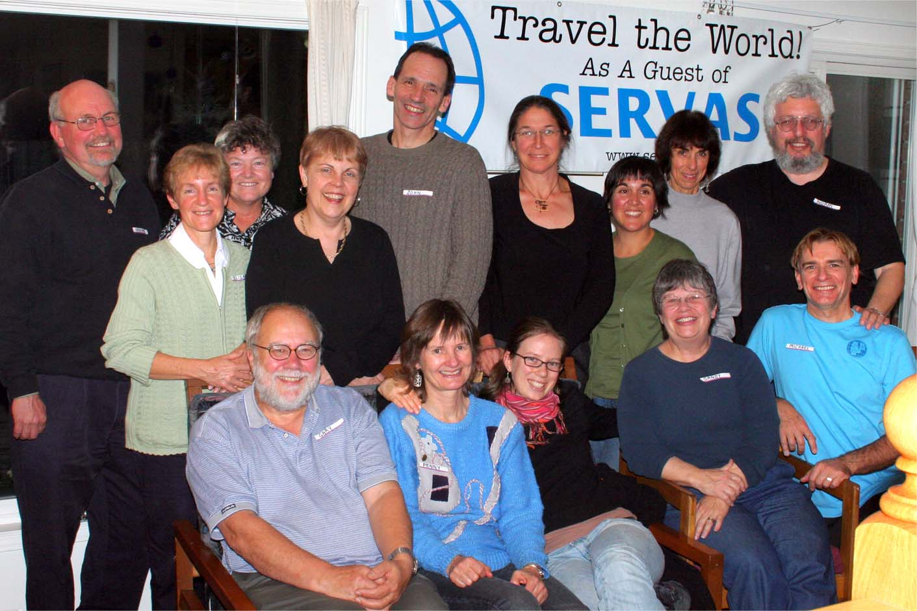
From left standing: Graham [neutral moderator], Elizabeth [Treasurer], Julie [Assistant NS], Sylvia [Peace Sec.], John [observer], Claude [new Board member], Michele [observer], Lesley [Newsletter Ed.], Norm [minute-taker]. From left, seated: Gary [SI pres.], Penny [NS.] Sarena [new, Youth Rep.], Sandy [Host List Coordinator], Michael [Board member and host of the meeting].

5. Servas Canada Operating Expenses
Just in case you were wondering where the fee for travelers goes, the Treasurer, Elizabeth Sebestyen, reminds us that 17 Swiss francs per traveler goes to Servas International in the form of stamp fees, which are used for international administrative expenses and support to the developing Servas countries. Other expenses are paid in accordance with the Servas Canada spending policy which provides priorities and guidelines for the payment and reporting of expenses related to Servas Canada operations. Mandatory priorities include the provision of Servas Canada host lists; provision of application forms and information for travelers; provision of foreign host lists to Canadian travellers and refunds of host list deposits as required; financial assistance to delegates to Servas international conferences and face-to-face Board meetings (held every two to three years in different regions of Canada); and provision of the newsletter to Canadian hosts. The Board of Directors recognizes that while Servas Canada is a non-profit organization run entirely by volunteers, operations must be managed with good business sense and accountability yet at the same time allow for some measure of flexibility and discretion on the part of officers. The latter therefore decides the amount of Servas Canada’s donations to a) Servas International, namely the Development Fund and cost assistance to Servas countries with demonstrated financial need, b) to non-Servas charitable organizations (3% of previous year’s gross revenues) and c) other worthy causes as agreed to by a majority of the Board.

6. Servas Malawi Deputy Secretary visits Canada
Sylvia Krogh, Servas Canada’s Peace Secretary in Edmonton, has established a strong bond with Malawi, all because of a squash game! Read on.
Ben came to Edmonton in the summer of 2005 to represent Malawi by playing squash – and winning a medal - at the World Masters Games. Ben stayed with Sylvia and they became friends. Ben is married to Servas Malawi’s National Secretary, Demelza Lewis-Benbow. So, in January 2007, after visiting Egypt, Kenya and Tanzania, Sylvia and her husband Alan continued south and went to see Demelza and Ben in Blantyre, Malawi. Ben and Demelza, both British expatriates, are very social, active, outgoing and friendly and they have really developed Servas in their adopted country. They were busy, but told Sylvia and Alan that they couldn’t leave without visiting the beautiful Lake Malawi, about five hours drive away. The Deputy National Secretary, Mary Boloweza was able to accompany them and serve as their interpreter so they could communicate with hitchhikers they picked up and with the many people Mary knew en route. They even visited her farm/village and met her aunt, uncle, brother, cousins, etc. Mary proved to be a very friendly, social, and adaptable person, so made friends easily.
Not surprisingly, Sylvia and Mary kept in touch.
As it happened, the following August Servas UK sponsored Mary Boloweza to attend and represent Africa at the UK Servas conference. Mary stayed with hosts in England and participated in three volunteer United Nations environmental work camps.
As she was so (relatively) close, Sylvia and Alan sponsored her to come on to Canada in October. Michael Johnson and Dafi Galad hosted Mary in Cambridge, Ontario and arranged for her to stay with other hosts in Toronto and area. Then Mary went on to Edmonton where she met the Edmonton hosts at a potluck gathering. Her social life was so full ─ meals, functions, walks, choirs, sailing, birthday parties, etc.─ that she was not able to partake in all of them! She spoke in school classrooms and shared information about Malawi and her work there as an AIDS HIV prevention educator. She was also introduced in the Alberta Government Legislature. “She is really a great ambassador for Malawi,” says Sylvia.
Mary went on to visit Servas hosts in Calgary, Victoria and Comox with activities planned for every day, each one offering Mary a great opportunity to meet many Canadian Servas hosts. She was amazed at how large Canada is and surprised that most Canadians don’t know where Malawi is. She especially enjoyed the snow and making snow angels as she had never experienced the white stuff before! Mary has now returned to the UK to participate in another volunteer work camp before returning to Malawi. Sylvia says she thanks all the Servas hosts who made Mary’s time in Canada so memorable. She adds, “As well Alan and I really enjoyed the opportunities to meet such wonderful Servas Canada hosts. It enriched our lives and reinforced what a great organization we belong to! May you all have such rewarding travel and experiences with Servas!”

7. Extracts from an enthusiastic traveler’s report
2007 was a truly spectacular travel year for me. After my illness the previous year, which reminded me once again that life is short, I decided that I would take, not one, but two trips this year so that if anything happened I would have no regrets. And so, I spent the month of April in Italy, where I stayed with a handful of “new” Servas families and also revisited three sets of friends in different parts of the country, all of whom I originally met directly or indirectly through Servas.
Then, in May, I attended a conference in London, Ontario, staying with old Servas friends and was lucky to participate in a regional Servas picnic with them that weekend. From there, I took off for what I consider to be the best trip of my life (and I have had many wonderful trips!). I was gone 21/2 months and zigzagged my way across the country (west) and back. I drove in my little Echo up the Alaska Highway to Whitehorse, then down the Cassiar Highway to Prince Rupert, then took the ferry to Vancouver Island, spent time on some of the islands, and, well, it felt like it would never end. Each place I went was spectacular. In 78 days, I had only two days where it rained enough to stop me from doing what I would have liked. Basically, it was one sunny day and one star-filled night after another. I stayed with about nine Servas families. I also spent time with non-Servas friends, and a few relatives. A lot of the time, I simply slept in my car. Altogether, I drove 18,960 km.
One of the highlights was staying with Nancy Barnes-Smith and her husband Peter, Servas members south of Calgary. I had originally planned to visit Nancy the previous year, as an add-on to a conference I was then hoping to attend, but had to cancel that trip after being diagnosed with cancer. (I am fine now, by the way.) Although I had never met Nancy, we kept in occasional contact throughout my illness, and after, I wrote her to thank her for her support and to say that we might meet one day after all, because I planned to one day drive across the country. Nancy emailed back and said, “Debbie, get out the Servas book and get out the maps and start planning that trip!” Nancy thought it would be therapeutic. Well, I thought about it and decided that this was a great idea. So I also have Nancy – and Servas!– to thank for getting me to do that trip when I did.
(Debbie Parkes, long-time host residing in St. Bruno, QC, and experienced Servas traveler)

8. Bits and bats

2008 Host List
The 2008 Canadian host list will be mailed to every Servas Canada host family, in April or May. Included in the mailing will be the Servas International Newsletter and Servas Canada financial statements. If you do NOT want to receive this mailing package, please contact us as soon as you read this by sending an email toCanada@servas.org.

Project Funding
You will perhaps remember an article in the past about a great project in Comox, Vancouver Island, which brought a couple from Honduras to stay with Servas hosts in B.C. and have a chance to experience the Canadian way of life. And in this issue you will read the story of Mary from Malawi. Servas Canada helped to fund both these projects which were initiated by one or several Servas members and approved by the Board. The ideas were admirable and may inspire others to launch similar projects: who does not meet wonderful worthy people less fortunate than ourselves in the countries where we travel? Before you become too involved and make too many promises, however, please consider getting a group together to prepare a formal request for financial assistance to the Board. We have had extra funds in the past but due to a shrinking membership and annual commitments to Servas International, we cannot fund every project that you may come up with.

9. Credits
This edition of the Servas Canada newsletter was written by Lesley R�gnier.
Translation from English to French was provided by Jean-Guy Charland, Lesley R�gnier and Dani�le Monfette.
Host list addresses were provided by Jim Leask. Robert Dar-Woon took care of e-mail distribution. Gerry Staring handled the mailed copies. Alvaro Barba posts the newsletter to the Servas Canada web site.
If you have ideas or contributions for the next Servas Canada newsletter, please forward them to canada@servas.org.
Copyright © 2000 - 2008 Servas Canada

